General Chemical Hygiene Plan

Table of Contents
Introduction 2
Security and Safety 2
Laboratory Specific Chemical Hygiene Plan 3
Assignment of Responsibility 3
Hazard Identification 6
Product Labels 7
Safety Data Sheets 8
Notice Boards and Signage 9
Hazard Assessment 9
Hierarchy of Controls 10
Elimination/Substitution of Hazards 10
Engineering Controls 10
Administrative and Work Practice Controls 11
Proper Lab Attire and Personal Protective Equipment (PPE) 12
Chemical Storage and Transport 12
General Rules for Chemical Storage 12
Chemical Transport within the Lab 13
Chemical Transport from Lab to Lab 13
Chemical Inventory 14
Health Hazards and Toxicity 14
Monitoring of Hazardous Exposures 16
Medical Consultation and Examinations 16
Accident Reporting 16
Chemical Waste Disposal and Spill Control 18
EH&S Compliance Controls 18
Resources 20

Introduction
The purpose of the Chemical Hygiene Plan (CHP) is to familiarize students, volunteers and employees with the University of Florida's safety and health policies regarding chemical use. By authority delegated from the University President, the Vice-President for Business Affairs is responsible for the safety of all University facilities. Under this authority, policies are developed to provide safe teaching, research, services, housing, and recreational environments. The CHP is a written policy which sets forth engineering controls, procurement controls, work practices, personal protective equipment, and procedures that:
- Are intended to protect individuals from the physical and health hazards presented by hazardous chemicals use in laboratories and research.
- Meet the requirements of the Occupational Safety and Health Administration’s (OSHA's) standard on Occupational Exposure to Hazardous Chemicals in Laboratories (29CFR1910.1450).
The complete Chemical Hygiene Plan for all University of Florida research spaces consists of the University of Florida Chemical Hygiene Plan and a Laboratory-Specific CHP.
The CHP must be readily available to all employees, students, and affiliates working with or handling chemicals in a laboratory/research space. The CHP will be reviewed annually by Environmental Health and Safety (EH&S) and be revised, as necessary. Records of the review will be maintained on file at EH&S. The Principal Investigator and lab staff shall review and update the Lab-Specific CHP on an annual, and as needed, basis.
This CHP covers all lab and science related endeavors at all University of Florida sites, both on and off campus. This also covers UF staff who are working in non-UF facilities, whether they be leased, or wholly owned by some other entity who has invited staff to work in that space. If invited into a space, staff must understand that their UF CHP and their host’s CHP must be abided by, as each has a responsibility for the workers in their care and in their facilities. Example: the host must provide a safe workplace and training about the site and work, but if injured, UF would be responsible for the Workers Comp program the injured worker would be covered under.

Building a Safety Culture
The intent of this, and any safety program, is to build and support a safety culture within the organization. The culture of safety is one where all staff work together towards a safer workplace, can share ideas, and provide feedback (positive and negative) freely with each other, and have their efforts supported by their administration. A culture of safety is not one that can be initiated just by someone saying, “we have one.” It must evolve over time and grow through effort, training, and acceptance by all.

Security and Safety
The partnership between staff, students, EH&S, and the University Police Department is active and must be maintained. All staff, students, and visitors are encouraged to stay aware of their surroundings and if they notice anyone or anything suspicious, they need to contact UPD at 352-392-1111 or 911. It is essential that all students, staff, and visitors follows UPD advice “if you see something, say something.”

Laboratory Specific Chemical Hygiene Plan
Each Principal Investigator must complete a Laboratory-Specific Chemical Hygiene Plan to document potential hazards specific to their lab and safety procedures required to reduce exposure to these hazards. The Lab-Specific CHP is completed and updated annually, or as the scope of work changes, through the Laboratory Assessment, Training, and Chemical Hygiene (LATCH) module in Gator TRACS. This will act as a lab specific CHP and must contain the following elements:
- Lab roster with designation of roles
- Training records for lab personnel
- Completed hazard assessment approved by the Principal Investigator. This will also list PPE required to be worn when performing these tasks.
- Signatures from all personnel on the roster, certifying their knowledge and compliance with the risk assessment and SOPs prior to working with the hazard and if/when the scope of work changes.
- Standard operating procedures (SOPs) for each specific lab activity involving hazards. EH&S provides SOPs templates and examples on the website.
- If the hazards present in the lab include, acute toxins, select carcinogens, or reproductive toxins, the lab CHP must include:
  - The establishment of a designated area where these would present.
  - Required engineering controls such as fume hoods, biological safety cabinets or glove boxes.
  - Written procedures and training provided for safe handling and removal of contaminated wastes.
  - Written procedures and training provided on decontamination procedures for equipment, spills, etc.

Assignment of Responsibility

Chemical Hygiene Officers (CHO) are individuals who can provide technical guidance in the implementation of this CHP. The EH&S Manager/Assistant Director for Laboratory Safety will function as the Chemical Hygiene Officer for the main University of Florida campus. Each off-campus location will designate an individual to function as a CHO for their labs. This individual will be the PI of the lab unless otherwise delegated.

The University of Florida will help with the compliance efforts of all staff and researchers. It will foster an attitude that safety is of the utmost importance and will support the efforts of all staff in creating and growing a culture of safety.

Environmental Health and Safety is responsible for working with faculty, staff, students, and others to develop and implement appropriate safety practices and procedures The responsibilities of EH&S and the CHO include (but are not limited to):
- Developing, implementing, and managing a comprehensive safety program for the University.
- Facilitating the campus community’s understanding of, and compliance with, required chemical health and safety regulations.
- Updating the CHP on an annual, and as needed, basis.
- Providing resources and guidance to Principal Investigators and laboratory staff on the development and implementation of Laboratory or site and/or task specific CHPs.
- Reviewing and aiding labs with their specific LATCH and chemical inventory
- Maintaining the Laboratory Safety Manual.
- Overseeing university-wide research safety inspections.
- Assisting Principal Investigators in the selection of appropriate laboratory safety practices, administrative controls, personal protective equipment, and engineering controls.
- Offering safety training and educational services.
- Coordinating and implementing hazardous waste disposal.
- Providing spill control and clean-up assistance.
- Providing personal monitoring for chemicals in the workplace as needed.
- Providing information and guidance through a variety of platforms including the EH&S website.
- Investigating all reported incidents which result in the exposure of personnel or the environment to hazardous chemicals.
- Assisting all UF workplaces in developing a safety culture. Nurturing as the safety culture develops and matures.

The Departmental Chairperson or Director shall be responsible for all personnel within their department engaged in the laboratory use of chemicals as follows:

- Providing budgetary resources, to ensure health and safety of the departmental personnel, visitors, and students.
- Providing training to PIs and staff members or allowing time for necessary training.
- Working with EH&S, to address reoccurring violations or unsafe conditions.
- Ensuring all faculty, students and staff are following the University’s General CHP.
- Supporting staff and lab’s efforts in developing and evolving a culture of safety within the departmental workplaces.

The Principal Investigator has the primary responsibility for providing and maintaining a safe work environment and for ensuring compliance with all elements of the University and Laboratory CHPs within their own research spaces. The Principal Investigator must:
- Develop and implement the Laboratory CHP and LATCH through the Gator TRACS website.
- Review and approve SOPs, ensuring that PPE, engineering controls, and work practice controls described within the SOPs provide adequate protection to staff.
- Ensure that PPE and required safety equipment are available and in working order and that laboratory staff is trained in their use.
- Determine training requirements for laboratory workers based on their duties and ensure appropriate safety training specific to laboratory/research area operations has been provided.
- Ensure that staff are knowledgeable on emergency response plans, including fires, equipment failure, chemical exposures, and chemical spills.
- Provide access to manufacturers’ Safety Data Sheets (SDSs), the University and laboratory-specific CHPs, the laboratory safety manual and other safety-related information.
- Maintain up-to-date chemical inventories.
- Correct or arrange for the correction of any unsafe conditions identified within the workspace through either self-inspections or inspections by EH&S or other authorized safety professionals.
- Contact EH&S on any work-related injury/illness, exposure, or near-miss incidents.
- Ensure proper disposal of hazardous materials according to university procedures.
- Investigate the circumstances surrounding a workplace accident and take steps to avoid recurrence.
- Maintain compliance with UF policies and procedures.
- Support a safety culture as it develops and evolves within the labs.

Individual laboratory workers are responsible for their safety and the safety of their co-workers and visitors to their laboratories. All staff must demonstrate this responsibility in their actions and attitudes. It will be each laboratory worker’s responsibility to:
- Follow campus and laboratory practices, policies, safety manuals and SOPs as outlined in the University and Laboratory CHPs.
- Attend all safety training as required by EH&S, the Principal Investigator and/or designee.
- Perform procedures and operate equipment that they have been explicitly authorized to use and trained to use safely.
- Wear appropriate lab attire and PPE.
- Develop good laboratory hygiene habits such as handwashing, housekeeping, maintaining PPE in good condition, etc.
- Dispose of hazardous waste according to university procedures.
- Report unsafe acts, injuries, spills, and near-miss incidents to the Principal Investigator.
- Understand the concept of a “safety culture” and the teamwork involved. Work to incorporate safety culture into the lab’s everyday workings.

Training

All employees, students, volunteers, and affiliates of research spaces must complete required training at the time of initial assignment to the lab and prior to assignments potentially involving new exposure situations. Some training courses may require regular updates or renewals. EH&S Chemical Hygiene Plan (EHS869) training is required and is completed using the MyTraining platform. Other hazard specific trainings may be required, and a list of EH&S training can be found here EH&S Training Courses.

Most importantly, lab staff must receive hazard and site-specific training for potential hazards found in the workplace prior to starting work and annually thereafter. The Principal Investigator (or another designated and knowledgeable individual) must conduct this training. The lab must record this training and keep these records indefinitely for each staff member.

Training must include:
- Contents and the location of the UF CHP and lab specific CHP, SOPs, etc.
- Information on the permissible exposure limits of the hazards they may be exposed to.
- Signs and symptoms of exposure to hazardous chemicals.
- Location of reference materials about those hazardous chemicals that staff may be exposed to. This includes, but is not limited to, information on the SDSs for these chemicals.

Hazard Identification

A complete chemical inventory of all chemicals found at the worksite shall always be maintained current. This shall be updated at least annually, made available for staff or compliance officer review, and provided to EH&S when requested.

As defined by the Occupational Safety and Health Administration’s (OSHA’s) Hazard Communication publication, a hazardous chemical is “any chemical which can be classified as a health hazard, a physical hazard, a simple asphyxiant, a combustible dust, a pyrophoric gas or a hazard not otherwise categorized.” The Globally Harmonized System (GHS) of the Classification and Labeling of Chemicals was developed by the UN, and adopted by OSHA in 2012, to ensure the safe production, transport, handling, use and disposal of hazardous materials. GHS website. The system provides a simplified approach of communicating hazards in a uniform way using 9 pictograms, 2 signal words, 72 hazard statements and 116 precautionary statements.

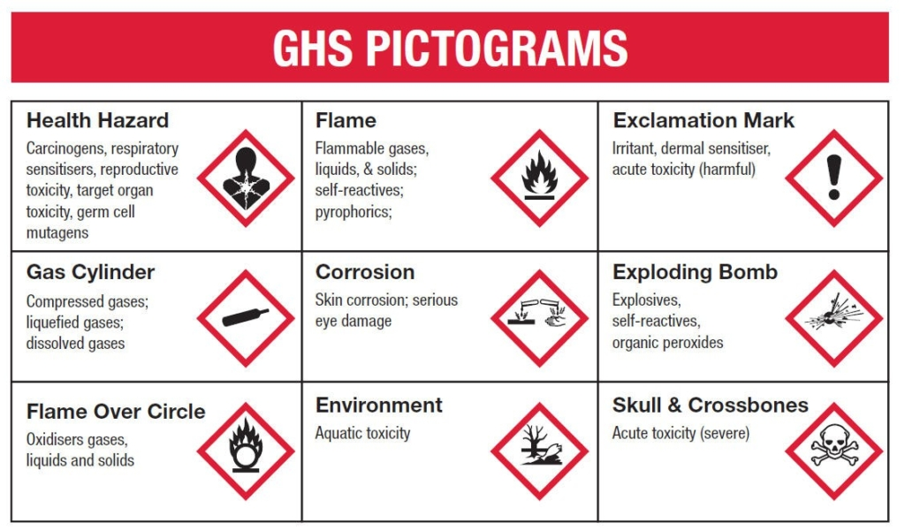
Figure 1. GHS Pictograms

Product Labels
Chemical manufacturers are required to use the GHS labeling system for the primary chemical container labels. There are six elements required in a GHS label:
- Precedence of hazard statement (signal word)
- Hazard statement text
- Pictogram
- Precautionary statement (Prevention, Response, Storage, Disposal)
- Supplementary hazard information
- Product Identifier (name)

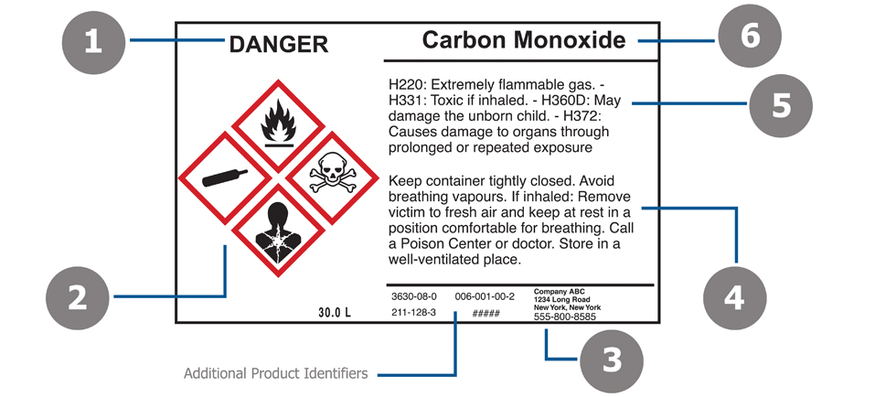
Figure 2. GHS Label
All substances transferred from an original container to a secondary container must be clearly labeled, including, flasks, beakers, etc. If abbreviations are used, a reference list of the abbreviations must be posted in the lab.

Safety Data Sheets
The Safety Data Sheet (SDS – formerly known as MSDS) is divided into sixteen sections providing essential information about hazards and safety precautions of a specific chemical or mixture. The sixteen sections include:
- Section 1: Product identifier and supplier information
- Section 2: Hazard identification
- Section 3: Composition and ingredient information
- Section 4: First-aid measures
- Section 5: Fire-fighting measures
- Section 6: Accidental release measures
- Section 7: Handling and storage
- Section 8: Exposure control and personal protection
- Section 9: Physical and chemical properties
- Section 10: Stability and reactivity
- Section 11: Toxicological information
- Section 12: Ecological information (optional)
- Section 13: Disposal considerations (optional)
- Section 14: Transport information (optional)
- Section 15: Regulatory information (optional)
- Section 16: Other information
As required by OSHA’s Hazard Communications Standard, an SDS must be available for each chemical used or stored in the laboratory. These can be accessible online, in a shared folder/drive, through the inventory management system, or via hard copies for laboratory staff to review at any time. The SDSs must meet the GHS formatting. Old Material Safety Data Sheets (MSDS) are not acceptable. If a hard copy paper file of SDSs is maintained, it must be reviewed and updated every 2 years. See Appendix 1 for an example of GHS labeling within an SDS.

Notice Boards and Signage
Laboratories, chemical storage areas and other potentially hazardous work areas shall have a notice board at all entrances into the workspace. These notice boards shall have pictograms identifying the categories of potentially hazardous materials found in the lab and be considered a warning of potential hazards. Emergency contact information shall also be included to identify at least two individuals to contact in case of emergency. This Emergency Call List shall provide the names and after-hours phone numbers of those individuals who will know the chemicals, gases and other hazards that may be affected by an emergency in the laboratory.
A privacy Emergency Call List is available for staff who do not wish to have their personal contact information available to the public. This info is submitted to both UPD and EH&S annually. The Emergency Call List will indicate that this information is on file with both EH&S and UPD.
Other workplaces and chemical storage areas may have NFPA 704 placards (National Fire Protection Association 704 standard). A placard may be needed for each chemical, or the most hazardous ones, as these are not cumulative nor combined. These use blocks of blue, red, and yellow to identify Health issues (blue), fire ratings (red) and reactivity (yellow). The white space beneath these squares is reserved for additional hazards like SA for “simple asphyxiation” hazards or W for water reactive chemicals. A numerical code of 0-4 is also used to define the severity of the chemical, with zero being no hazard associated with the chemical, and as the numbers increase the hazard increases, with 4 being potentially deadly. These diagrams are explained further in Appendix 2.

Hazard Assessment
Each Principal Investigator will be responsible for assessing the hazards in the workspace by completing the LATCH assessment in Gator TRACS. These hazards may include chemical, biological, energy sources, equipment, physical hazards, processes, etc. The PI may assign a designee to complete the hazard assessment, but the assessment must be approved, and signed off, by the PI overseeing the space.
The assessment will identify the potential hazards associated with the work and provide suggested methods used to mitigate the hazard. Once the hazards are identified, it is important to determine the associated risk. For example, the risk associated with using 1 mL of hydrochloric acid will be different than the risk involved with using 500 mL of hydrochloric acid.
Any new potential hazards associated with the change of scope of work must be assessed and documented in Gator TRACS by completing a new LATCH hazard assessment. It is expected that the lab will also conduct a new risk assessment. These LATCH Hazard Assessments will be reviewed annually at a minimum.

Hierarchy of Controls
Once the hazards have been identified, the next step is to determine the appropriate control methods. The hierarchy of controls classifies control methods from most effective to least effective. When the use of hazardous chemicals is necessary, the preferred controls are those which remove the hazard from the workplace or place a barrier between the worker and the hazard (engineering controls) followed by work practices and then PPE.
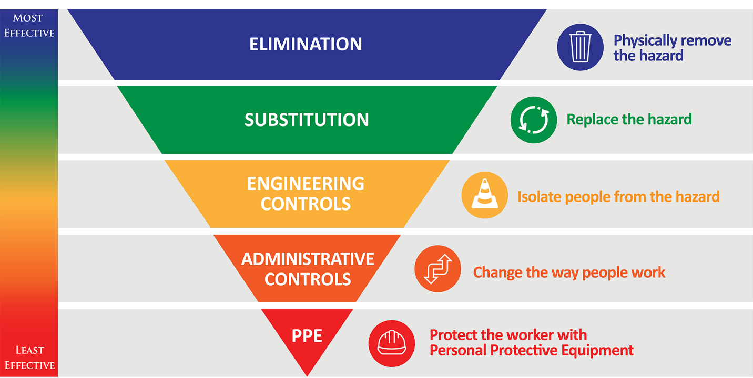
Figure 4. Hierarchy of Controls

Elimination/Substitution of Hazards
When planning research or clinical laboratory activities, consider the hazards of the chemicals that will be used. If possible, eliminating a chemical from being used would remove any hazards associated with it. Unfortunately, that is most likely impractical, but the risk can be reduced if an alternative product or procedure that uses a less hazardous chemical or that substitutes a less hazardous form of the same chemical is used. In addition, limit the quantity of chemicals used when possible; small scale or pilot experiments are preferred.

Engineering Controls
Devices or systems which remove the hazard from the workplace or place physical barriers between the staff member and the hazard, known as "engineering controls", will be employed to minimize or eliminate potential hazards in all labs. These may include fume hoods, biological safety cabinets, glove boxes, shields, increased ventilation, point source vapor collection (snorkels), etc.
Chemical fume hoods are the primary engineering control devices used to protect personnel and the laboratory environment from hazardous chemicals that may become airborne through volatilization or aerosolization. All work shall be performed a minimum of 4 inches back from the front edge of the hood. The sash must be lowered to the prescribed height as designated on the EH&S hood profile sticker attached to the face of the hood. The sash must be fully closed when there is no activity happening in the fume hood or when staff walk away from it.
EH&S will profile all fume hoods at least annually to ensure that the required face velocity and airflow are functioning as required. If staff have a concern about the hood’s functioning, they may request the hood to be profiled at any time. If, for any reason, the hood is not working correctly, all work in the hood must cease until the hood has been repaired. If the hood is not functioning properly, a work order shall be submitted to IFAS Facilities Operations at
352-392-1984, or the Facility Services Work Management Center at 352-392-1121 depending on the location of your fume hood. The lab staff may be responsible for clearing of all chemicals and equipment from the hood and cleaning any contamination from the hood’s surfaces prior to repairs. Facilities Services or IFAS staff may not be able to repair the fume hood if proper cleaning and decontamination has not been conducted by the lab. This is to ensure the safety of the workers performing the repairs.

Administrative and Work Practice Controls
Administrative controls are work procedures and policies designed to lessen the threat of a hazard.
Standard Operating Procedures (SOPs) complement the risk assessment with written procedures that explain how to utilize and manage hazardous materials and procedures to prevent and minimize health and safety concerns. Once the hazards are identified and the control measures are determined to decrease risk to an acceptable level, the information must be documented in a SOP as part of the lab-specific chemical hygiene plan. SOP templates and examples can be found on the EH&S website Standard Operating Procedures. Particularly hazardous substances require additional planning and considerations. OSHA defines particularly hazardous substances as carcinogens, reproductive toxins, or substances with high acute toxicity. Appendix 3 includes a list of particularly hazardous chemicals, as defined by EH&S, which necessitate additional requirements for SOPs. These requirements include establishment of a designated area, use of containment devices such as fume hoods or glove boxes, procedures for safe removal of contaminated waste and decontamination procedures.
Rules and Policies –The Laboratory Safety Manual provides guidance, rules, policies, and expectations for working in a scientific laboratory at UF. Additional references may be found on the EH&S website; Biological Safety Manual, the Laser Safety Manual, and the Radiation Control Guide.
Procurement Controls involve controlling personnel exposures by making chemical purchasing decisions that enhance workplace safety. For example, labs shall:
- Order only needed amounts – order an amount that will be used in the near future and avoid ordering larger quantities merely for the bulk discount. Having a larger amount on hand increases the risks to health, the environment, or property in the event of an incident.
- Order a less hazardous form of the same chemical – Use the logic below to help choose the least hazardous physical form that will work for your application.
  - Dilute solutions are safer than more concentrated solutions.
  - Aqueous solutions are safer to handle than powders requiring reconstitution.
  - Pellets, tablets, granules, or flakes are safer to handle than powders.
- Purchase the chemical in a safer container – order chemicals in shatter-resistant containers or other containers that enhance workplace safety.
- Check existing inventory before ordering.
- Check with the EH&S sponsored Chem Swap program for unused chemicals that are available free-of-charge.
Training - All researchers working in wet lab spaces must complete EH&S Chemical Hygiene Plan (EHS869) training prior to beginning work in the lab. Please contact the University’s Chemical Hygiene Officer if you need assistance with the Chemical Hygiene Plan.

Proper Lab Attire and Personal Protective Equipment (PPE)
Proper lab attire and PPE for work with hazardous chemicals includes lab coats, suitable/compatible gloves, eye protection, sturdy, full coverage shoes and clothing that fully covers the legs. Additional PPE shall be worn depending on the hazard and risk assessment and will be described in the work area-specific SOP. PPE shall be used by staff members as a final means of barrier protection against hazards, as there is no way to eliminate or reduce the hazard.
PPE shall be fitted to the individual and be specific for the hazard. Staff members must be trained in the wear and use of PPE. PPE may include specific gloves, safety glasses/goggles, face shields, flame retardant lab coat, gowns, aprons, and respirators as part of the Respiratory Protection Program. EH&S or manufacturer’s glove compatibility charts must be consulted to ensure that the gloves that are intended to be worn will protect the wearer.
The Principal Investigator and lab staff are responsible for PPE maintenance including inspection, care, cleaning, repair, and proper storage. PPE that is not performing up to manufacturer’s specifications, such as eye wear with scratched lenses that have lost their ability to withstand impact, or ones that are clouded, must be discarded.
If there are any concerns about the need for a respirator, please contact EH&S so an evaluation can be made. If there is a need for a respirator, the individual(s) will be placed into the Respiratory Protection Program. This will require a medical evaluation, proper fit testing of the respirator and training on use, care, and maintenance of the respirator.

Chemical Storage and Transport
The following sections highlight general rules for storing and transporting chemicals. Please refer to the Laboratory Safety Manual for more detailed information.

General Rules for Chemical Storage
- Do not store liquid chemicals above shoulder height of the person utilizing the chemical.
- Flammable chemicals in amounts exceeding 10 gallons cannot be left throughout the lab and must be stored in flammable storage cabinets or safety containers.
- Containers of liquids may not be stored on the floor unless they are placed in tubs or other leak-proof secondary containment.
- Excessive chemical storage in hoods is not acceptable; this practice interferes with the airflow in the hood and reduces the available workspace, increasing the chances for exposures, spills, etc.
- Store chemicals in compatible storage groups, and away from incompatibles – compatibility information is included on the chemical’s SDS. Refer to the Laboratory Safety Manual for more guidance.
- Flammable materials may only be stored in refrigerators or freezers designed for flammable storage. Flammable solvents stored in a standard household type freezer could cause a fire or explosion if they leak and there is a spark from the internal thermostat or light.
- Chemical waste shall be placed at the designated accumulation area, in appropriate receptacles, properly labeled and segregated by hazard class.
- Due to the lack of ventilation/recirculated ventilation, cold rooms cannot be used for the storage of hazardous chemicals or asphyxiants. Unless they are stored in a flammable storage cabinet.
- All compressed gas cylinders (regardless of size) shall be secured to racks, walls, work benches, or hand trucks by a strong chain or strap, or secured by any other approved method capable of preventing the cylinder from falling or being knocked over.
- Compressed gas cylinders must also be capped if they are not in use or have the regulator removed. Additional guidance can be found here Compressed Gas Safety.

Chemical Transport within the Lab
- Containers and bottles must always be labeled.
- Always use appropriate chemical resistant gloves and eye protection.
- Large containers or especially hazardous chemicals must be carried in a secondary container.
- Never move visibly degrading chemicals and containers. Report these to your lab supervisor or PI. Contact EH&S Hazardous Waste Management at 352-392-8400 for advice or disposal.
- Be aware of your surroundings: potential trip hazards, other workers, etc.
- Spill absorbent materials and SDS for the chemicals must be always available.

Chemical Transport from Lab to Lab
In addition to the parameters listed above for general chemical transport, the following protocols apply for transport of chemicals outside of the lab environment.
- Use sturdy carts for transporting multiple, large, or heavy containers; the cart shall have wheels large enough to negotiate uneven surfaces without tipping or stopping suddenly.
- Carts used for secondary containment must have a liquid-tight tray capable of containing the entire contents of the primary container.
- Chemicals should not be transported during busy times, such as during class changes, lunch break, etc.
- Transport hazardous chemicals on freight elevators, wherever possible, to avoid exposure to persons on passenger elevators.
- As a rule, gloves are not to be worn outside the lab. However, if gloves are necessary for transport, wear a glove on the one hand used to handle the hazard and use the ungloved hand to open doors and push elevator buttons, etc.
- Never leave chemicals unattended.
- Materials that are unstable, explosive, or acutely hazardous must not be moved before contacting EH&S.
- Transport cylinders only on a hand truck or other cart designed for cylinder transport. The cap must be in place and the cylinders secured to the cart by straps or chains when transporting the cylinders.

Chemical Inventory
Accurate inventories of hazardous chemicals are required for local emergency responders and compliance with regulatory agencies such as the Dept. of Homeland Security, Environmental Protection Agency, and the Florida Dept. of Environmental Protection. For these reasons, laboratories, shops, and studios must maintain an accurate inventory of all chemicals in the Gator TRACS Chemical Inventory module. The inventory will be reviewed at the time of the safety survey. Emergency responders need to know what hazardous chemicals are stored in UF facilities when responding to a fire or spill. During emergency events, EH&S responders will provide chemical inventory data to emergency responders.

Health Hazards and Toxicity
A chemical that may cause injury or irritation to any part of the body and in any way, must have some controls listed for handling that compound. The criteria for determining whether a chemical is classified as a health hazard can be found in the Hazard Communications Standard 29CFR 1910.1200, Appendix A. This list includes acute (single) and chronic (repeated potentially over extended periods of time) exposures. These may cause irritation, cancer, reproductive issues, sensitization, etc.
The risk of exposure is dependent on several factors.
- The route of exposure and how the chemical may get into the body.
- The dosage that the individual may encounter. This is the amount of compound that is getting into the body over time.
- Toxicity, the degree of how poisonous a compound is.
- Duration is the length of time that an individual has the exposure.
The mechanism that the chemical may enter the body is considered the “Route of Exposure.” There are four routes that this can occur:
- Inhalation - breathing the vapors into the respiratory track. This will affect the nasal passages, trachea, lungs, etc.
- Absorption - this usually occurs through a skin exposure or exposure of vapors through the eyes.
- Ingestion - purposely or accidently consuming the chemical through the mouth. This may also occur by eating or drinking something contaminated by the chemical.
- Injection - forcibly having the chemical pass through the skin into the body. This can be through a needle stick or from a contaminated glassware cut.
The dosage is defined as the amount of harmful substance that the individual is exposed to. This is usually in conjunction with time, or duration.
Toxicity is influenced by the health of the individual; their age, illnesses, gender, lifestyle and previous exposures to this or other toxic substances. Examples would be the increased risk an individual may experience from an exposure to an airborne chemical inhaled into lungs damaged by smoking or the reduced risk a male may experience after exposure to a chemical that may affect female reproduction.
Besides the chemical effects on a body, there are other hazards, such as physical hazards, where a body may be damaged from the effects of an explosion, electrocution, fire, extreme heat or cold, from a radioactive material, intense lights including lasers, etc. The CHP must also address these hazards. Protection strategies can be employed:
- Fire - minimize quantities being used. Eliminating sources of ignition. Vent flammable gases from the workplace.
- Reactive and explosive chemicals - use smaller quantities, utilize engineering controls, such as barriers and fume hoods.
- Protecting from cold may include minimizing time spent in cold rooms or freezers, wearing protective clothing (jackets, gloves, and hats), etc.
- Working in heat can be extremely hazardous, but personnel can protect themselves by minimizing exposure time, working in cooler parts of the day, increasing fluid intake, wearing “cold vests.” Heat Stress Policy
- The EH&S Electrical Safety policy is found at Electrical Safety Policy Staff can protect themselves by not modifying existing equipment, having all equipment inspected by a qualified individual prior to use, wearing arc flash PPE, wearing flame retardant PPE, etc.
- Prior to using radioactive sources or emitters, staff must have these registered with EH&S Radiation Safety Staff using radioactive materials must complete training and wear a dosimeter to monitor amount of exposure.
- Light from lasers can damage eyes including causing blindness. Proper training must be taken prior to use. Proper eye protection specific to the wavelength of the light source must be worn. Barrier protection to ensure the laser does not escape the work area must be used. Lasers may need to be registered with EH&S. LASER Safety

Signs of Exposure
Some chemicals may be immediately evident through their smell, visible vapors, smoke, etc. Others may cause immediate or delayed physical symptoms like headaches, irritation to eyes, nose, mouth or respiratory track or skin. Long term illnesses like cancers may take specialized exams and equipment to detect. Staff must pay attention to how they feel, sudden changes in their environment, etc., and act on them immediately.

Monitoring of Hazardous Exposures
Suspect elevated chemical exposures shall be referred to, and investigated by, the EH&S Industrial Hygiene (IH) group. Initial monitoring will be performed as required for chemicals of concern or those being regulated. The results of exposure monitoring, if conducted, will be compared to currently accepted occupational exposure limits (OEL). The findings may require modifications to work process or the implementation of more effective engineering controls (local exhaust ventilation) to control exposures. The individual who was being monitored will be provided a report.

Medical Consultation and Examinations
Always call 911 for a medical emergency. Go to the nearest ER for any exposure. It is highly recommended that you bring a copy of the safety data sheet, concentration, and volume of the chemical hazard when you visit the care provider to expedite treatment. Do not bring the chemicals itself!
Non-emergent medical attention or medical evaluation is available to all who work with hazardous chemicals in the laboratory, under the following circumstances:
- Whenever signs or symptoms associated with exposure to a hazardous substance develop.
- When exposure monitoring reveals an exposure level above the action level for an OSHA regulated substance for which there are exposure monitoring and medical surveillance requirements.
- Whenever an event takes place where employees are exposed to hazardous substances (i.e. - chemical spill, release, explosion, etc.).
- Whenever an eyewash or safety shower has been used as the result of a spill or splash.
When there is the need to wear a respirator or when there is potential animal contact, staff must go through the Respiratory Protection Program or Animal Contact Program prior to work.

Accident Reporting
In a medical emergency, please call 911. Please note that all lab staff must know the physical address of the building and lab room number. It is recommended that this information be posted near the lab’s phone. Notify your supervisor immediately.
For non-life-threatening work-related injuries or illnesses involving chemicals, employees shall call AmeriSys at 1-800-455-2079. AmeriSys is the State of Florida’s medical case management provider and charged with directing injured workers towards the proper care facility. Treatment for any non-life-threatening work-related injury or illness must be authorized by AmeriSys prior to obtaining medical treatment. Self-identify as either an employee or UF Volunteer and provide the injured worker’s UF ID number. Worker's Compensation

Accidents can be reported to EH&S by the submission of the Injury Investigation Report form.
The medical consultations and examinations will be provided at no charge to the employee, without loss of pay and at a reasonable time and place.

Chemical Contact and Exposures
If possible, after an exposure or chemical spill onto a staff member, staff will provide initial first aid:
- Eyes - immediately flush eyes at an eyewash station for 15 minutes. Ensure to open eyes to get under eyelids. Seek medical attention.
- Body - flush body for 15 minutes under and safety shower station. Remove clothing to flush all skin areas. Seek medical attention.
- Inhalation - get injured worker to fresh air. Seek medical attention immediately.
- Ingestion - seek medical attention immediately.
- Hydrofluoric Acid exposure
  - Eyes - flush for 5 minutes and seek medical attention immediately.
  - Skin- flush for 5 minutes after removing clothing. Treat area with calcium gluconate gel. Seek medical attention immediately.

Fire in the lab
Enact R*A*C*E
Rescue and remove all injured and mobile staff from the area.
Activate the building alarm if building is equipped with one. Call 911. Ensure to know the buildings street address.
Contain smoke and fire by closing doors after the room has been searched. This will limit smoke spread in hallways and stairwells used for evacuation.
Evacuate the area and go to safe place. Ensure to be available for other follow-up questions from emergency responders.
OR
Extinguish the fire if you have been trained on how to use a fire extinguisher and one is available. Remember P*A*S*S
Pull the pin.
Aim at the base of the fire from 6-8 feet away.
Squeezer the triggering handle
Sweep spray from side to side and move closer when the fire is being extinguished.
Remember:
- If the choice is made to fight a fire, ensure:
  - that the staff’s back is to the exit so they can evacuate quickly if needed.
  - that staff have the training to use the extinguisher.
  - that only one extinguisher is used per fire. If the fire is not extinguished with one extinguisher, the fire is too big to fight. Drop it away from the area so it is not a trip hazard and evacuate the area.

Chemical Waste Disposal and Spill Control
If a chemical spill occurs, lab staff must decide if they can clean it up and if they have the materials to do a clean-up. If not, contact EH&S Hazardous Waste Management for assistance. If the spill is larger, call UPD at 352-392-1111 or 911. Spill Response » UF | EHS

EH&S will dispose of hazardous chemical and radioactive waste. A pick-up request must be submitted, with a listing of the substances that will be disposed. Labs must adhere to the Satellite Accumulation Area Requirements for hazardous wastes paying special attention to waste labeling. Hazardous waste labels are available through EH&S at no charge. Label all containers accurately, indicating the constituents and approximate percentage of each and marking the category of hazard(s) present. The concentration of the constituents must add up to 100%. If you use your own label, mark all containers conspicuously with the words “HAZARDOUS WASTE” and indicate the category of hazard(s) present (i.e., Flammable, Oxidizer, Corrosive, Reactive, Toxic). Lab staff will clean spills and contaminated areas if they have the correct spill control material, have been trained in proper and safe handling of the spilled material and can perform the cleanup safely. If there is any concern about the spill clean-up, the lab staff shall call EH&S to have the spill and area cleaned. All lab staff generating hazardous waste must take the Hazardous Waste Management training (EHS809) on a yearly basis.

EH&S Compliance Controls
EH&S will conduct a Safety Survey of each research area or laboratory on a periodic basis (typically once a year). The survey will evaluate chemical, physical, radiological, biological, and general safety in addition to a LATCH review. During this survey, any safety deficiencies will be noted in Gator TRACS by the surveyor and explained to lab staff. A link to the inspection report is then sent to each Principal Investigator identifying any concerns and the required corrections. The survey report and corrective actions will also be posted in Gator TRACS for all roster members to review. Corrective actions need to be addressed within 3, 7, 14 or 30 days depending on the severity of the deficiency. Follow-up surveys may be performed.
The following steps will be taken if the safety deficiencies are not addressed in a timely manner (extensions may be granted on a case-by-case basis):
- Once a corrective action is 30 days past due, the EH&S Coordinator who conducted the safety survey will send an email reminder with instructions on how to close open items. If more time is needed to address the issue, the lab may request a deadline extension through Gator TRACS.
- After 60 days, the program manager will send an additional email reminder if the corrective action has not been addressed or a deadline extension has not been requested.
- If there is still no response or extension request after 90 days, the Associate Director for Research Services will email a final reminder to the Principal Investigator. The issue will be referred to the Department Chair if there is no response after that point.
- If the PI and lab do not work towards compliance, EH&S can, and will, escalate this matter to the UF Office of Research, and notify that entity that the lab is not in compliance with UF requirements. EH&S may decide to close the lab until compliance is met.

Resources

OSHA Laboratory Standard- 29 CFR1910.1450

The OSHA Laboratory Standard is available at the UF Environmental Health and Safety Laboratory Safety Program Office. It can also be found at:

Occupational exposure to hazardous chemicals in laboratories

A general overview of the Laboratory Standard is available at:

OSHA Laboratory Safety Overview

Appendix 1:

Section 2 of an SDS includes information on GHS’s standardized system of dividing chemicals into classes and categories. Each class (flammable, carcinogen, oxidizer, etc.) has one or more associated categories indicated by a number or letter (refer to Figure 3 for example). Lower numbers indicate a higher hazard. Detailed information on the hazard classes and categories are found the official GHS website.
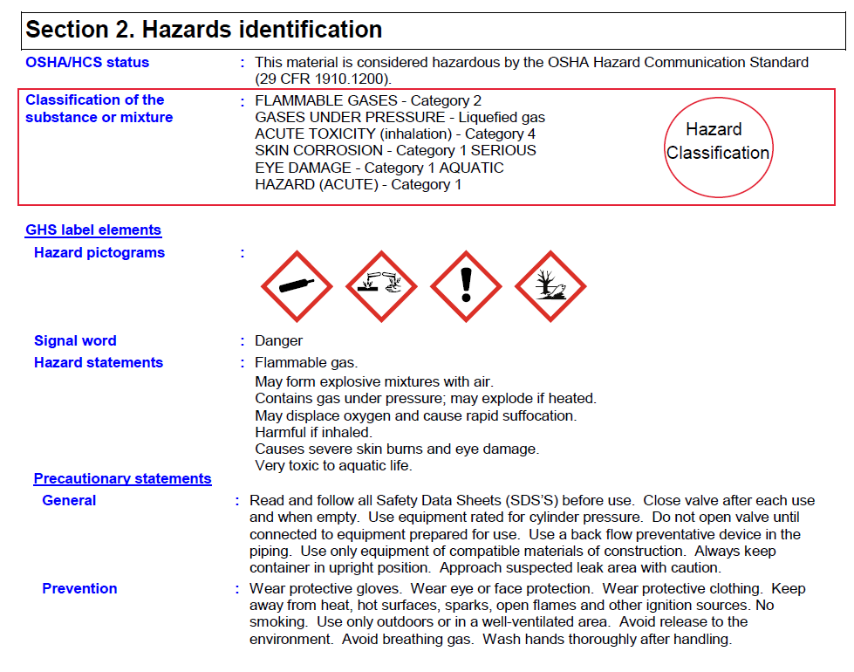

Appendix 2 - NFPA 704 placarding

Blue = Health hazard
Red = Fire hazard
Yellow = Reactivity hazard

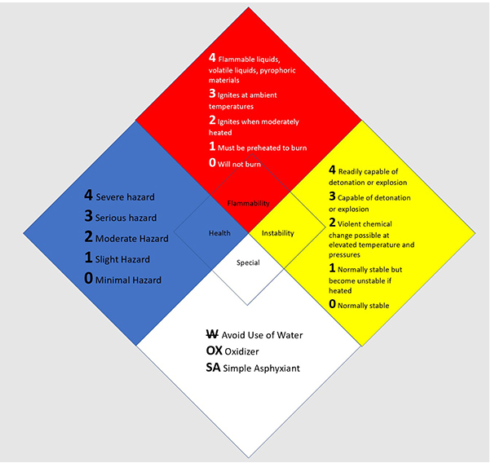
NFPA 704 standard NFPA Today November 05, 2021

Appendix 3: List of Particularly Hazardous Chemicals

Criteria for Particularly Hazardous Chemicals
Based on GHS* Labeling – found in Section 2 of the SDS

Select Carcinogens | - GHS Carcinogenicity category 1A or 1B  - IARC** Group 1  - NTP’s*** “Known to be Human Carcinogens”  - OSHA-listed carcinogens  - GHS category 2 AND IARC Group 2 (A or B), AND NTP “Reasonably Anticipated to be Human Carcinogens”
Reproductive Toxins | - GHS Category 1A or 1B
Chemicals Having High Acute Toxicity | - Acute toxicity by inhalation or dermal exposure GHS category 1 or 2  - Acute toxicity by oral exposure GHS category 1  - Specific Target Organ Toxicity—Single Exposure GHS category 1
Reactive & Explosive Chemicals Considered Particularly Hazardous | - Oxidizing liquid or solid GHS category 1  - In contact with water releases flammable gas GHS category 1 or 2  - Pyrophoric liquid or solid GHS category 1  - Explosives—unstable or divisions 1.1—1.3  - Explosive when dry, or explosive with or without air contact  - Self-reactive or organic peroxides—Type A or B  - Self-heating category 1
*GHS = Globally Harmonized System
**IARC = International Agency for Research on Cancer
***NTP = National Toxicology Program

