Automatic External Defibrillator (AED) Purchasing Information
If your department or group is interested in purchasing an AED, there are a few key things to know. The purchase and funds for an AED would be done through your department or group that wishes to purchase a unit(s). With that said, Environmental Health and Safety (EH&S) has been tasked with managing the overall AED program here at the University of Florida (UF). As EH&S works to standardize the AED program, ZOLL AED units emerged as the best fit for campus and are strongly recommended to be purchased. These ZOLL AED units include:
- ZOLL - Cardiac Science PowerHeart G5 | 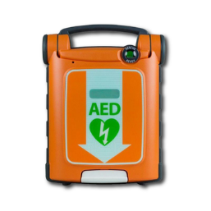
- ZOLL AED 3 | 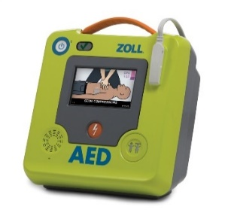
- ZOLL AED Plus | 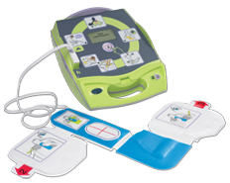
- Physio-Control LifePak CR2 | 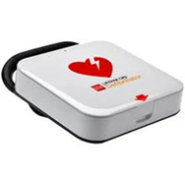

Why Purchase or Upgrade Your AED?
When someone experiences sudden cardiac arrest, their heart can go into a dangerous arrhythmia or irregular heartbeat called ventricular fibrillation (VF or best known as V-fib). V-fib is a life-threatening heart rhythm that if not corrected fast, can lead to loss of consciousness or certain death. At this point, time is of the essence. For every minute the heart is in V-fib, someone’s chances of survival decrease by 7-10%. An AED unit once placed on a victim, can recognize V-fib, and develop a shock to the heart, in hope to stop V-fib and get the heart back into a normal rhythm. Early defibrillation is key. To learn more about AED’s and sudden cardiac arrest, visit https://www.zoll.com/medical-products/automated-external-defibrillators/faq
Like any cell phone or machine, AEDs are no different. They all need to be properly maintained during their life cycle and then eventually replaced. If your department or group has an older AED unit that is either 10+ years old (past end-of-life), has a major recall that can no longer be supported or the company is no longer in business, it is strongly recommended to update your AED to one of these three AED options listed.
Where Should I Start?

What AED Should I Order?
All three of the recommended AEDs listed, come with the newest innovative technology, visual & verbal guidance and real-time rescuer feedback support while doing CPR. The choice on which of three AEDs should you purchase, we will leave up to you. To learn about these ZOLL specific public access AED units, visit https://www.zoll.com/products/aeds/aeds-for-public-access.
To purchase an AED unit(s), please remember to first contact EHS by submitting an email to request an approval of an AED purchase. We can also assist you further in discussing more about the recommended ZOLL units and what else you may need.
During the initial start-up purchase of your AED, each recommended model comes with a list of product features that may be included; a set of defibrillation pads, a 4-to-5-year battery with warranty, carry case, and more. Each new recommended AED unit also comes with a warranty. In addition to the AED unit purchase, most departments also buy one child defibrillation pad set (if applicable), an AED wall cabinet and an AED 3-D wall sign. These wall mount cabinets are usually placed within an area of the building that will make the AED unit(s) accessible for all to use if someone goes into cardiac arrest.
It is important to remember that batteries and electrode pads do have expiration dates and can be two items that will create a reoccurring cost every 2 to 5 years. These items are specific to the model unit and may not fit on a different style of AED unit. Remember, it is the expectation of the department or designated responsible group that has bought an AED to maintain their unit(s) in the rescue ready mode and according to the manufacture’s guidelines.
There is an array of authorized provider/ vendors that sell these three recommended AED units. It would be good to shop around and find the best price quote. You also may want to ask if these units are currently in stock before you order.
After Ordering
Once the actual AED unit arrives, it is important to register your new or updated AED with EH&S by adding to the COR AED Monitoring website: https://apps.ehs.ufl.edu/cor/devices. Remember to please complete all the fields. It is essential that EH&S knows:
- Model type and serial number
- Which department or group will be taking ownership and maintaining it (including contact information)
- The location of the AED (building, floor and/or room)
- Expiration dates for the electrode pads and battery, and
- Whether the AED is mounted in a cabinet, mobile or on a shelf
If an AED cabinet is purchased, it is strongly recommended to mount the cabinet in an accessible area (i.e. by restrooms, elevator lobby or public area). Since these cabinets can also protrude off the wall more than four inches in hallways of public travel, the ADA compliance height for the cabinet(s) must be 27 inches from the bottom of the cabinet to the floor. If you have facilities mount your cabinet, please be sure to advise them of this requirement. Lastly, a 3-D wall mount sign should be purchased and mounted above the cabinet to assist occupants in the building on identify where an AED is located from a distance.
If you have any questions or need additional assistance, please contact EH&S Coordinator by emailing aed@ehs.ufl.edu or calling 352-392-1591.

