PURPOSE
Describe relevant background information.

Aqua regia is a mixture of nitric acid and hydrochloric acid, usually in a molar ratio of 1:3. It is a fuming liquid that is colorless when freshly prepared but turns yellow, orange, or red within seconds from the formation of nitrosyl chloride and nitrogen dioxide. Aqua regia is primarily used to produce chloroauric acid. It is also used to clean glassware of organic compounds and metal particles and is preferred over chromic acid for cleaning NMR tubes as no traces of chromium can remain to spoil spectra. Because of the fast reaction of its components, aqua regia decomposes quickly and loses its effectiveness in a short period of time. It should be mixed immediately before use. Aqua regia is very corrosive and has been involved in several explosions due to mishandling. NEVER store aqua regia in a closed container as it will oxidize over time, pressurizing the container, making an explosion likely. Additionally, never store aqua regia in a metal container as it corrodes metal.

Scope
Identify the intended audience and/or activities where the SOP may be relevant.

This SOP is intended for lab personnel involved in the creation and usage of aqua regia for cleaning glassware in laboratories on UF campus.

Responsibilities
Identify the personnel that have a primary role in the SOP and describe how their responsibilities relate to this SOP.

- Identify personnel & responsibilities here.

Hazard Identification & Control Measures
Include information on how to handle a particularly hazardous substance or experimentation using a certain piece of equipment. Instructions might include recommended hazard control measures, PPE, chemical transportation, and storage. Describe transport, receiving, and storage requirements. Include secondary containment, transport devices (carts, carriers, etc.), segregation requirements, any special temperature or atmospheric requirements, and container compatibility requirements.
A. Potential Hazards
- Chemical Hazards (CH): Strong oxidizer (liquid, solid, or gas), potentially explosive, water-reactive, corrosion to metals, corrosive (skin and/or eye damage), acute toxicity (oral, dermal and/or inhalation), and target organ systemic toxicity: single exposure
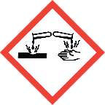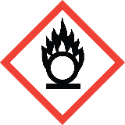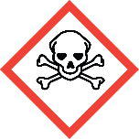
- Biological Hazards (BH): None
- Physical Hazards (PH): None
- Electrical Hazard (EH): None
- Other Hazards: None
B. Engineering Controls / Administrative Controls
Fume hood, splash shielding, and venting caps for storage and waste containers. Vented caps are designed to release gas slowly and WILL NOT release pressure from a vigorous reaction.
C. Personal Protective Equipment (PPE)
Safety glasses, lab coat: chemical resistant or not 100% cotton, gloves (nitrile when there is minimal risk of exposure), acid resistant gloves (neoprene, butyl, viton), acid resistant apron (recommended, but not required if amounts are less than 100 milliliters), and face shield or goggles.

Procedure
Provide the steps required to perform this procedure (who, what, when, where, why, how).
Aqua Regia should be made fresh for each work period. Carefully consider the amount needed before making the solution. Try to keep the total volume created for each batch to 100 ml or less.
Preparation of a 1:3 solution:
1. Identify the location of the nearest eyewash and safety shower. Ensure equipment is unobstructed.
2. Don a lab coat, disposable gloves, and lab goggles, or safety glasses with a face shield.
3. Move the parent bottle of nitric acid and the parent bottle of hydrochloric acid to the fume hood
4. Measure out hydrochloric acid equivalent to 3/4 the final volume desired
5. Carefully pour the hydrochloric acid into a glass container at least double the size of the final volume
6. Measure out nitric acid equivalent to 1/4 the final volume desired
7. Slowly pour the nitric acid into the glass container with the hydrochloric acid
a. The solution will heat up as the nitric acid is added and may exceed 100ºC
8. If storing the solution, it must be stored in a glass container (preferably Pyrex) with a vented
cap, must be kept in the fume hood, and cannot be stored for any longer than a few hours
Use for cleaning glassware:
1. Don lab coat, nitrile gloves, and safety glasses
2. Gather all glassware to be cleaned and place in the same fume hood as the aqua regia
3. Identify where the cleaned glassware will be placed, glassware should not be placed on any paper towels or organic materials as any residual acid may cause combustion
4. Have a waste bottle available for the collection of the used aqua regia
a. The bottle should be rinsed with water and allowed to dry to be sure there is no organic residue.
5. Have sodium bicarbonate on hand to neutralize any spills.
6. Don heavy-duty acid-resistant gloves over disposable nitrile gloves, and switch from safety glasses to either goggles or face shield with safety glasses.
7. If using aqua regia previously made earlier that day, carefully open the vented bottle as the contents may still be pressurized
8. Carefully pour a small volume of aqua regia into the glassware to be cleaned
9. Swirl the acid around the glassware being careful to not spill any
10. Empty the acid into the waste container and loosely cap
11. Place the rinsed glassware in the previously identified location
12. Repeat steps 8-11 for all glassware to be cleaned
13. Once all glassware has been cleaned, ensure all containers of aqua regia and waste are closed with vented caps and stored in the fume hood
14. Thoroughly clean the work surface with soap and water, neutralizing any visible spills with sodium bicarbonate first
15. Wash the reusable gloves before doffing PPE

Special Handling and Storage Requirements
List applicable precautions for preparation and storage.

Must be stored in the fume hood, ideally in a glass Pyrex secondary container, can only be stored for a few hours, vented caps are required.

Waste Disposal Procedures
List the types of waste (solid or liquid), the expected amount of waste generated, and how the waste should be handled when performing the procedure. Also list the hazard determination (flammable, oxidizer, corrosive, reactive, toxic) of the generated waste.

- Solid Waste: Solid waste generated is toxic.
- Liquid Waste: Liquid waste generated is corrosive, oxidative, and toxic.
Waste must be collected in glass bottles, not metal. 100 ml or less of liquid waste should be produced per run. Minimal solid waste should be generated. If using aqua regia to clean glassware of precious metals, the liquid waste will be toxic as well.

Disposal procedure and location of Satellite Accumulation Area: Waste must be stored in bottles with vented caps, waste bottles must be stored in the fume hood with the sash closed or a splash shield around the bottle. Waste must not be stored more than 2 weeks from the oldest mixture date.

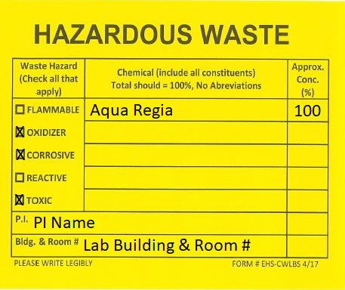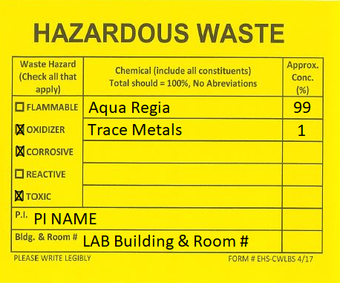

Emergency Response (Spill & Accident Procedures)
Indicate how spills, personnel exposure/injury, and other accidents should be handled and by whom. List the physical address on campus.

Exposure:

• Skin or Eye Contact: remove contaminated clothing and accessories; flush the affected area with water for 15 minutes, get medical attention.
• Inhalation: move person into fresh air, get medical attention.
• Ingestion: rinse the mouth with water, get medical attention.

Life-Threatening Emergencies (fire, explosion, large-scale spill or release):

• ACTIVATE THE BUILDING’S FIRE ALARM SYSTEM IF THE SPILL REPRESENTS A THREAT TO HUMAN LIFE OR MAY CAUSE A FIRE OR EXPLOSION.
• Notify all persons in the workspace that a spill has occurred an-d evacuate all personnel from the workspace to a safe location.
• Isolate the workspace to prevent inadvertent entry: lock any access doors, place signs on doors reading “DO NOT ENTER CHEMICAL SPILL”
• Call EHS at 352-392-8400 for clean-up assistance. If the emergency occurs outside of normal work hours, contact the University Police Department at 352-392-1111.

For minor spills (< 50 mL) or releases that can be cleaned up by local personnel:

1. Notify personnel in the area and restrict access.
2. If trained and confident, apply acid neutralizer wearing PPE described above including face shield. Otherwise, contact EHS at 352-392-8400.
3. Absorb with polypropylene, vermiculite, or pearlite absorbent after neutralization.
4. Collect spill cleanup materials in a closed container. Manage spill clean-up debris as hazardous waste.
5. Submit online waste pickup

Emergency Contact Numbers:

- Principal Investigator: xxx-xxx-xxxx
- Lab Manager: xxx-xxx-xxxx
- Building Manager: xxx-xxx-xxxx
- Poison Control Center: 800-222-1222
- Emergency: 911
- EH&S: 352-392-1591

Physical Address on Campus:

Add your lab’s address here.

References
List resources that may be useful when performing the procedure, for example, Admin policies, standards, etc.

Add references & resources here.

Documents and attachments
List applicable forms that are required to be completed in the SOP. Attach any documents used in support of the SOP, e.g., flowcharts, work instructions, pictures or diagrams, forms, and labels.

List applicable forms and attachments here.

